**Data Visualisation 2: Ski Europe**

**Tej Sidhu**

<https://github.com/thedevLEGEND27/data-viz-2.github.io>

**Domain, Why & Who:**

The domain that I want to explore is Ski Tourism. I plan on going holiday in Europe so this data and visualisation is intended to help those in a similar boat to make informative decisions.

The dataset that powered the insights is from Ski-resort-stats.com (Ski Resort Stats) and the data of the weather is from Wikipedia (Wikipedia). The geographical data which the ski data was projected onto comes from Natural Earth (Natural Earth).

**What:**

From the perspective of a ski tourist, I want to capture excitement by first delving into the peaks and which countries may interest them. I found a dataset on Kaggle.com which pulled stats from Ski Resort Stats from the year 2022 Feb. This data then had to be cleaned and matched to with the geographical dataset. All this was done in Vega Lite. The weather dataset I got from Wikipedia had to be data wrangled with cleaning, pivoting for it to be usable. I ended up writing two python scripts which prepared the data for Vega lite.

Figure 1: Ski Data Visualization, Tej Sidhu

**Why and How:**

My visualization contained 7 idioms. Going top to bottom I will explain my choices for them.

1. Figure 1
   1. This is a choropleth map with colour saturation used to show the peak heights. Because the data is geographical/nominal in nature and the values are quantitative this is a very quick way for the user to visualise the data.
2. Figure 2
   1. I used a heatmap because you can see trends on a high-level vs seeing values. This reduces the cognitive load. I did this in Vega by making my data temporal and mapping it to the x-axis.
3. Figure 3
   1. A simple bar graph for a simple statistic. I aggregated the number of resorts by country and presented them in this format.
4. Figure 4
   1. I used a multi-line plot to highlight the variance in peaks by country so users can decipher a region interesting to them based on their skill level. This also has interactivity like the other charts with a tooltip to easily access the values.
5. Figure 5
   1. An aggregated bar graph to present a break down on slope by level. This is the best way to represent categorical and quantitative data through area.
6. Figure 6
   1. A box and whisper plot is the best way to educate users about what the range of price they can expect to pay - the most and least. I did this using the min-max box plot.
7. Figure 7
   1. Breakdown of the daily expenses is best suited to a pie chart so you can see which items will make up most of the cost and then you can make an informative decision about where you can save.

**Design:**

**Layout**

The visualisation takes the format of a magazine style of storytelling. The goal is to be informative and therefore it takes them down in a sequential order. This carries a linear progression. This is predominantly done with the header 1 titles.

**Colour**

I kept the colours simple as the magnitude and discrete nature of the data is harder to convey with colour alone. Because of the winter theme in this visualisation, I used colder colours such as blue, green when relating to peaks. Later using orange, red, blue for other categorical data.

Primary colours red and green was avoided for colour blindness except in the packed bubbles where colour was not a mark.

**Figure Ground**

The visual hierarchy is built through the size of the elements and the linear scrolling progression. The design is very cantered and balances the white space delicately, not appearing too empty or distracting from the visualisations.

**Typography**

Arguably, one of the key factors influencing the visualization's coherence is the choice of Helvetica, a globally recognized symbol of simplicity. Employing bold weights in the titles aligns with Gestalt's principle of connection, effectively grouping related elements and guiding the viewer's visual flow.

**Storytelling**

I used catchy titles to tell a story from first building the users excitement about the heights of ski resorts to then guiding them to make a choice about where and when they see themselves potentially going based on weather and resort data.

**5 DESIGN SHEETS**

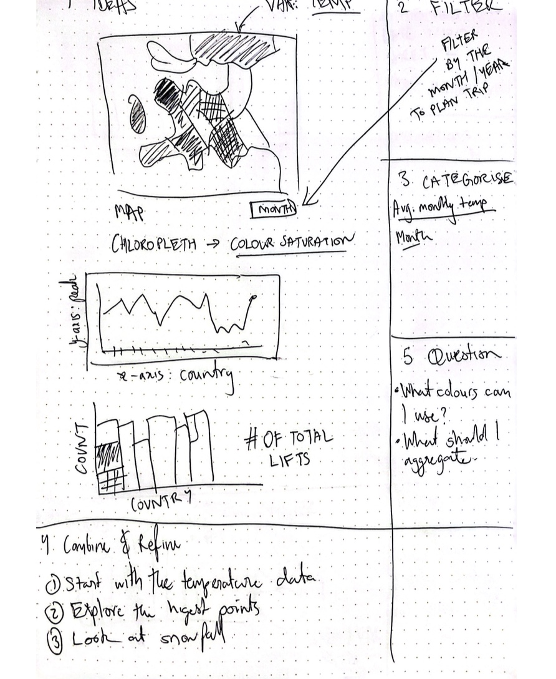

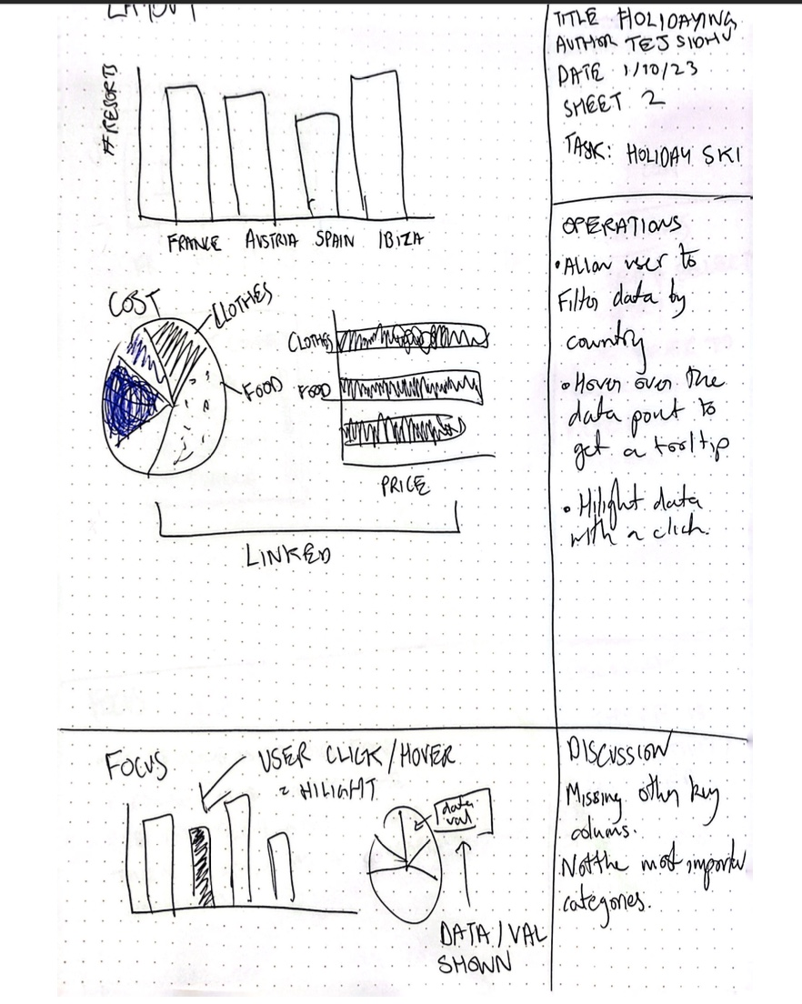

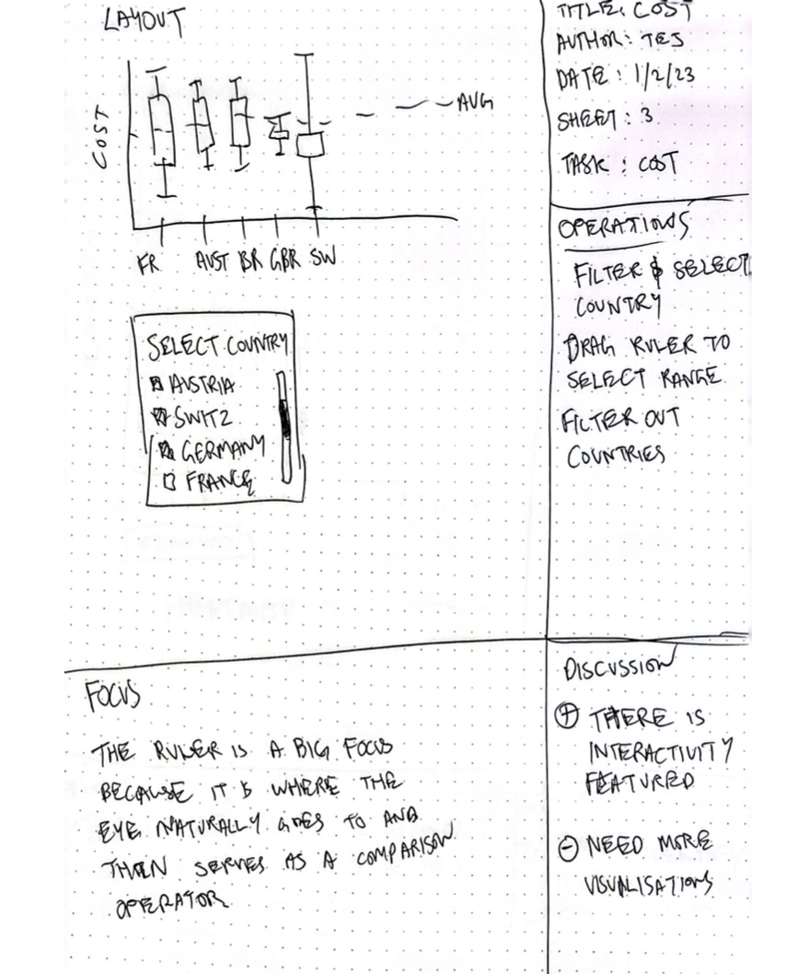

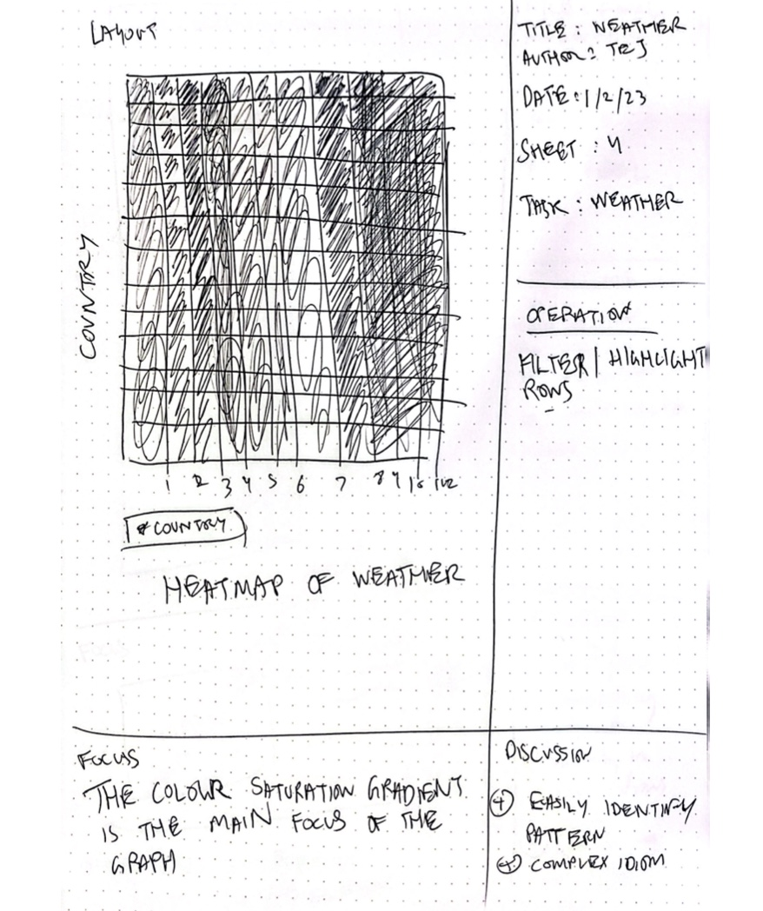

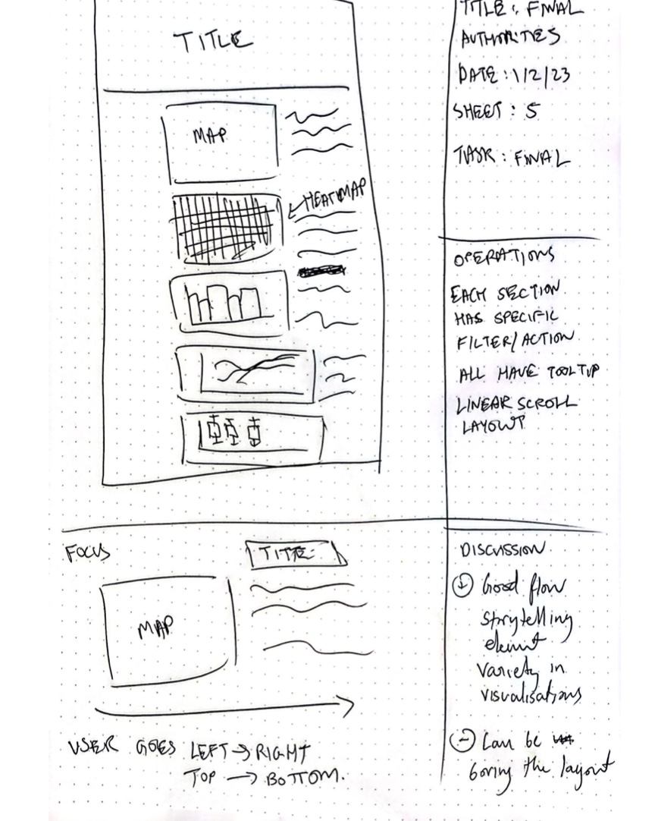

**Bibliography**

**Datasets**

Ski Resort Stats (n.d.). Retrieved from <https://www.kaggle.com/datasets/thomasnibb/european-ski-resorts>

Wikipedia Temperature of Countries by Month (n.d.). Retrieved from <https://en.wikipedia.org/wiki/List_of_cities_by_average_temperature>

Natural Earth (n.d.). Retrieved from

<https://www.naturalearthdata.com>